**Output**

**Part 1:**

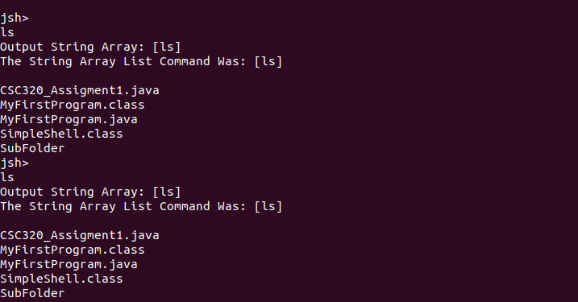

*Running the ls command within the terminal from the virtual computer*

**Part 2:**

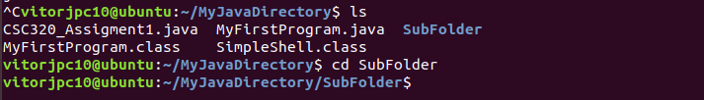

*Desired Output*

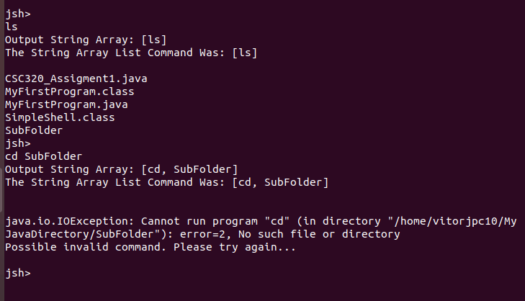

*Actual output*

Unfortunately, even after the use of the *.directory* method (starting a line 101) I was unable to set the new directory even after considering the use of *getProperty* and calling all the parameters accordingly to the type of user command input.

**Part 3:**

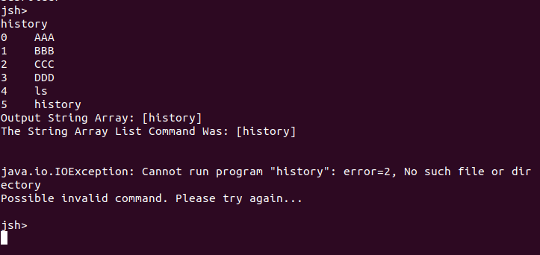

Calling history command

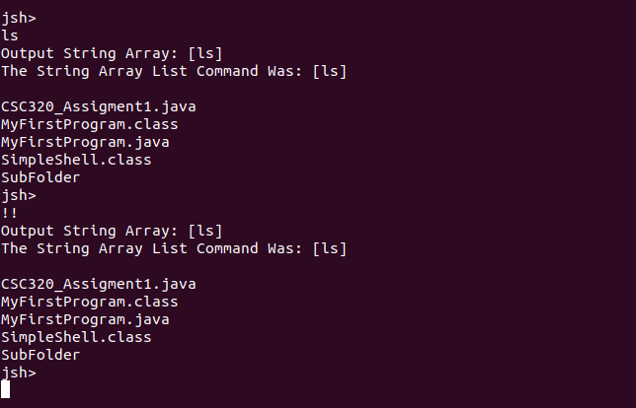

Calling the !! command

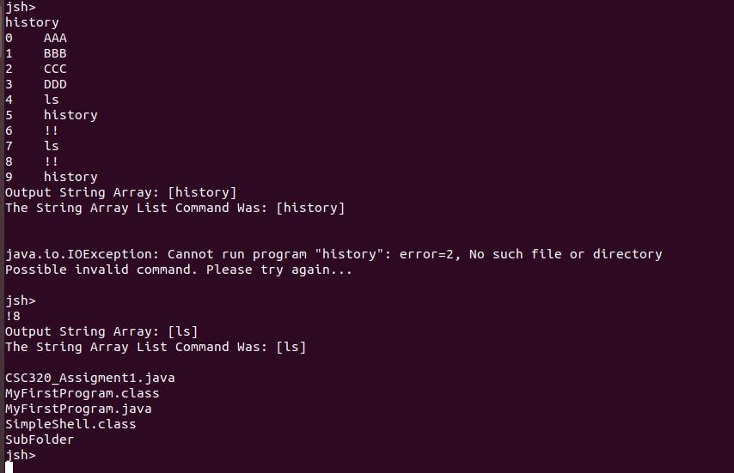

Calling the !# command (Where # is any number within the command history). In this case !8 was called.